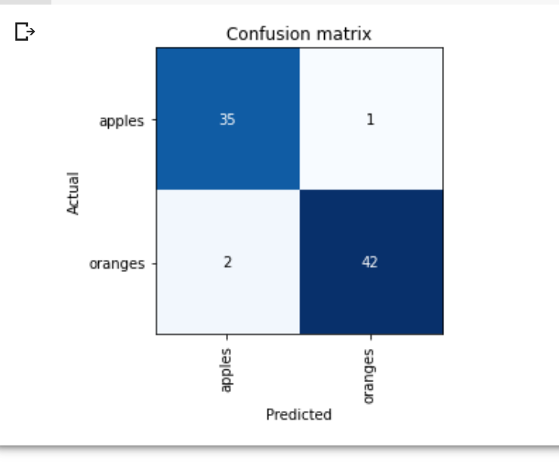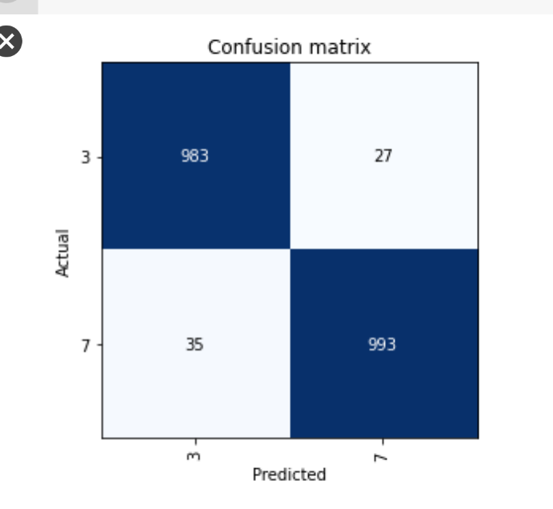

This process was honestly really cool. I’ve spent a lot of time beginning YouTube series about deep learning but I’ve never really gone through because they often start with terminology and understanding concepts rather than a practical application. I like how in the actual guide video, he explains more about himself and the fact that his/this course starts with actually a practical guide into real world applications of deep learning.
What surprised me was how easy of a process this was. I often read science fair projects from people I know who describe having to manually determine layers and things like that – I don’t know much about that, but to make something that can tell whether an image is a dog or a cat in around 10 lines is really surprising.
I honestly also wonder how long it would take to create a perceptrons network from scratch that could do this same thing. I also find it interesting how 8 years ago, they split the images of dogs and cats up into three different body parts to analyze them. It shows how fast things change (59% accuracy to 99.999% accuracy).
The tutorial was pretty easy to follow along – the issue I had was weird and I doubt anyone else has or had that issue. I couldn’t find anything about it online, I just kept clicking on prompts from Google Colab and eventually fixed it.
Overall, this was honestly a really cool project that I’m glad we did. It definitely opens up a lot more easier ways to study practical AI online.

